Sensor Fusion Nanodegree

# Lidar Obstacle Detection

# Radar

## Radar Principles

### The Radar Sensor

The image below shows how radar sensors are used along with a full suite of other sensors in an autonomous vehicle:

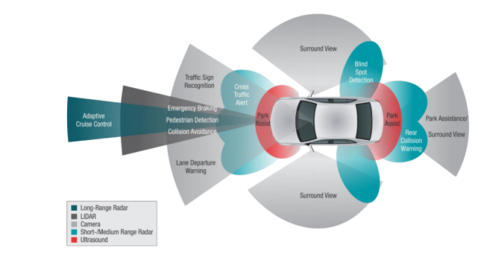

**Radar Operation**

Radar works using the transmission and detection of electromagnetic waves as seen in the following image:

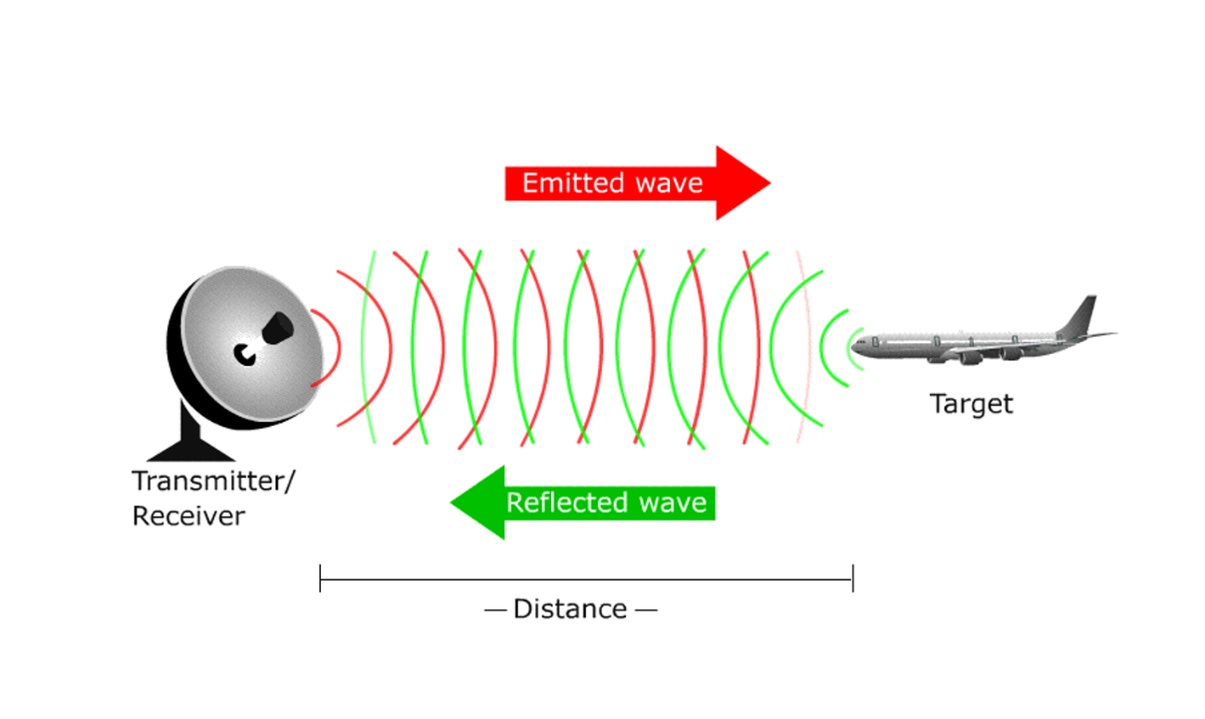

The electromagnetic waves are reflected if they meet an obstacle. If these reflected waves are received again at the place of their origin, then that means an obstacle is in the propagation direction. The frequency of electromagnetic energy used for radar is unaffected by darkness and also penetrates fog and clouds. This permits radar systems to determine the position of road targets that are invisible to the naked eye because of distance, darkness, or weather. Modern radar can extract widely more information from a target's echo signal than its range.

**Radar Construction**

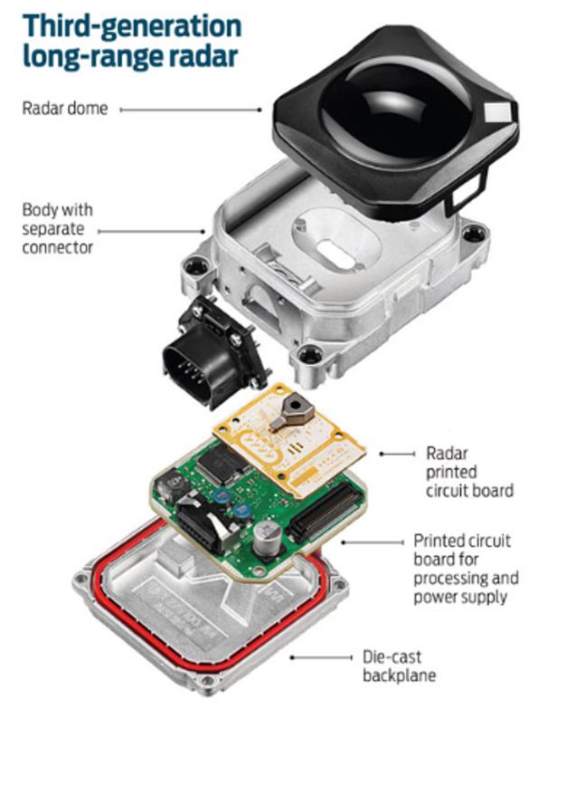

The automotive radars are small size sensors that can easily fit beneath the front grill or the bumper. As seen in the image above a radar module comprises of different parts.

*Radar Dome or Radome*: A radome is a structural, weatherproof enclosure that protects a radar antenna. The radome is constructed of material that minimally attenuates the electromagnetic signal transmitted or received by the antenna, effectively transparent to radio waves.

*Radar Printed Circuit Board*: This is analog hardware that includes the radar transceiver and antenna needed for radio wave generation.

*Printed Circuit Board and Processing*: This includes the Digital Signal Processing (DSP) unit.

**Radar vs Lidar**

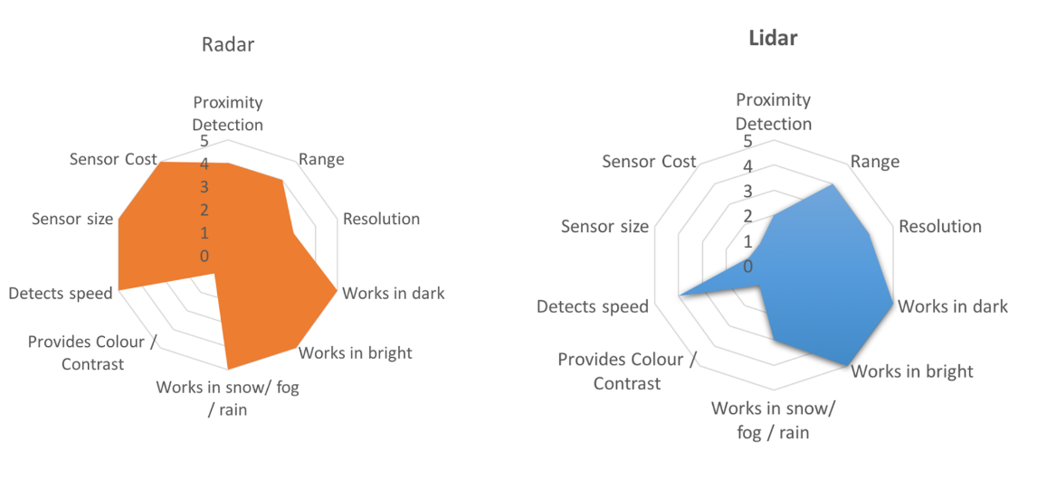

LIDAR can generate high resolution imaging based on reflection of the laser light off from the targets. But LIDARs fail in bad weather conditions as the very small wavelength doesn’t allow to work well in fog or rain. Additionally, LIDAR is an expensive sensor with costs varying from $35,000 to $100,000 as of 2019.

Radar lacks the capability to generate a high resolution image, but it has highly accurate velocity estimation based on the doppler phenomenon. Also, radar wavelength allows it to sense the targets in bad weather conditions as well. Most important is the low manufacturing cost for a Radar. A radar unit can cost as low as a few hundred dollars, allowing a car manufacturer to deploy multiple Radar sensors for 360 degree perception.

### Signal Properties

**Signal Wave Parameters**

Wavelength (λ) is the physical length from one point of a wave to the same point on the next wave, and it is calculated as

λ = $\frac{speed of light}{frequency}$

The higher the frequency the smaller the wavelength.

The *frequency* of a wave is the number of waves that pass by each second, and is measured in Hertz (Hz). The automotive radar generally operates at W band (76GHz - 81GHz). The signal at this frequency is referred to as millimeterWave since the wavelength is in mm.

The *Bandwidth* of a signal is the difference between the highest and the lowest frequency components in a continuous band of frequencies.

The *Amplitude* is the strength of the signal. Often it corresponds to the power of the RF signal/electromagnetic field defined in dB/dBm. It is relevant while configuring the output power of the radar and sensing the received signal. Higher the amplitude of the Radar signal, more is the visibility of radar. Automotive Radar can operate at max of 55 dBm output power (316 W)

**Phase of a Signal**

Phase is a particular point in time on the cycle of a waveform, measured as an angle in degrees. A complete cycle is 360°. The phase for each argument value, relative to the start of the cycle, is shown in the image below, in degrees from 0° to 360° and in radians from 0 to 2π.

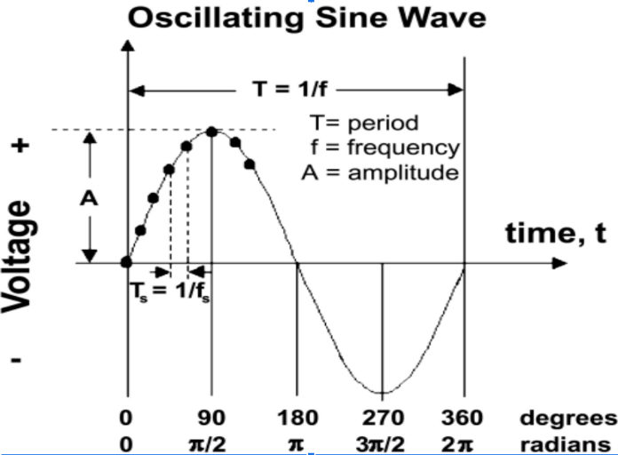

The frequency can also be defined as the first derivative of the phase with respect to the time.

$frequency= \frac{dφ}{dt}$ where $φ=phase of the signal$

The difference between the phases of two periodic signals is called the phase difference. At values of when the difference is zero, the two signals are said to be in phase, otherwise they are out of phase with each other.

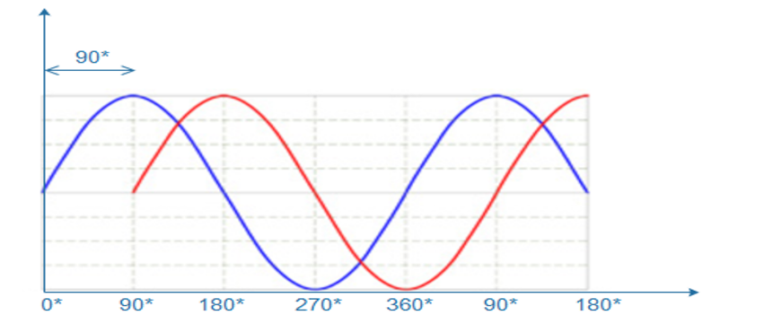

**General Equation of a Wave**

A wave travelling in space is defined by the following equation:

$y\left(t\right)=A cos⁡(2π*f_{c}*t+ φ)$

### FMCW

FMCW radar (Frequency-Modulated Continuous Wave radar) is a special type of radar sensor which radiates continuous transmission power. FMCW radar’s ability to measure very small ranges to the target as well as its ability to measure simultaneously the target range and its relative velocity makes it the first choice type of radar for automotive applications.

**FMCW Chirps**

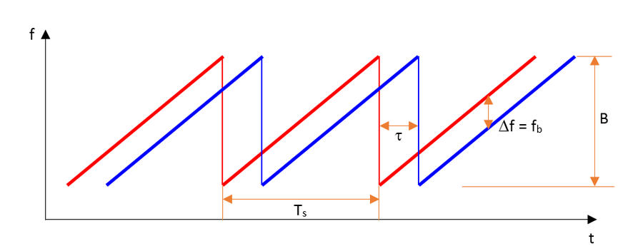

A Frequency Modulated Continous Wave (FMCW) is a signal in which the frequency increases/decreases with time. They are also referred to as upramps and downramps. The two most common waveform pattern used for FMCW radars are sawtooth and triangular. The sawtooth waveform generally uses just the upramps, whereas the triangular waveform uses both upramps and downramps.

Each chirp is defined by its slope. The slope is given by its chirp frequency bandwidth $B$ or $B_{sweep}$ (y-axis) and its chirp time $T_{s}$ (x-axis). Hence,

$Slope= \frac{B}{T_{s}}$

The range resolution requirement decides the $B$, whereas the maximum velocity capability of a radar is determined by the chirp time $T_{s}$.

One chirp sequence or segment comprises of multiple chirps. Each chirp is sampled multiple times to give multiple range measurements and radar transmits in order to measure doppler velocity accurately.

### FMCW Hardware and Antenna

**FMCW Hardware Overview**

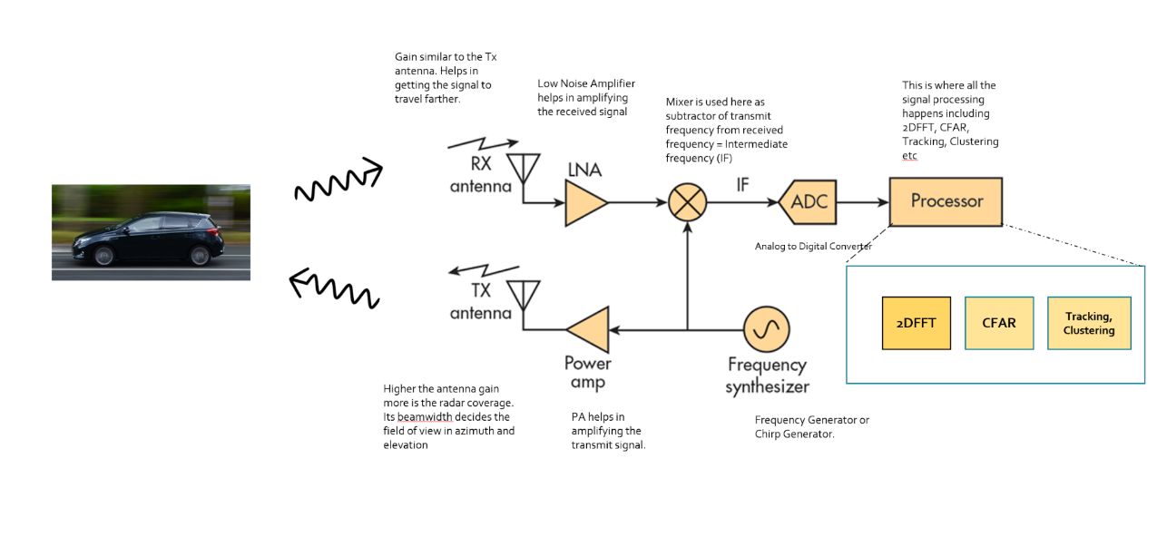

*Frequency Synthesizer*: The frequency synthesizer is the component that generates the frequency to bring the chirp frequency all the way to 77GHz in case of automotive radar.

*Power Amp*: The power amp amplifies the signal so the signal can reach long distance. Since the signal attenuates as it radiates, it needs higher power (amplitude) to reach targets at greater distances.

*Antenna*: The antenna converts the electrical energy into electromagnetic waves which radiate through the air, hit the target, and get reflected back toward the radar receiver antenna. The Antenna also increases the strength of the signal by focusing the energy in the desired direction. Additionally, the antenna pattern determines the field of view for the radar.

*Mixer*: In FMCW radar, the mixer multiplies the return signal with the sweeping signal generated by the frequency synthesizer. The operation works as frequency subtraction to give the frequency delta - also known as frequency shift or Intermediate frequency (IF). IF = Synthesizer Frequency - Return Signal Frequency.

*Processor*: The processor is the processing unit where all the Digital Signal processing, Detection, Tracking, Clustering, and other algorithms take place. This unit could be a microcontroller or even an FPGA.

**Antenna Details**

As defined in the FMCW Hardware definitions, the antenna is a transducer that converts the electrical energy into electromagnetic waves. In the case of radar, these waves travel through the air and hit the target. Depending on the surface type and shape of the target, the waves get partially reflected back in the direction of the radar. The receiver antenna at the radar amplifies the received signal further and sends it to the receiver chain for further processing.

**The Antenna Pattern**

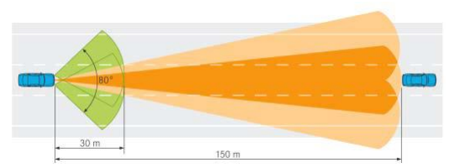

The *antenna pattern* is the geometric pattern of the strengths of the relative field emitted by the antenna. The *beamwidth* of the antenna determines the field of view for the radar sensor. If the requirement for the radar is to just sense the targets in its own lane then the beamwidth needs to be small enough to cover the complete lane up to desired range. If the beamwidth is wider than the lane width, it will sense the targets in the other lanes as well.

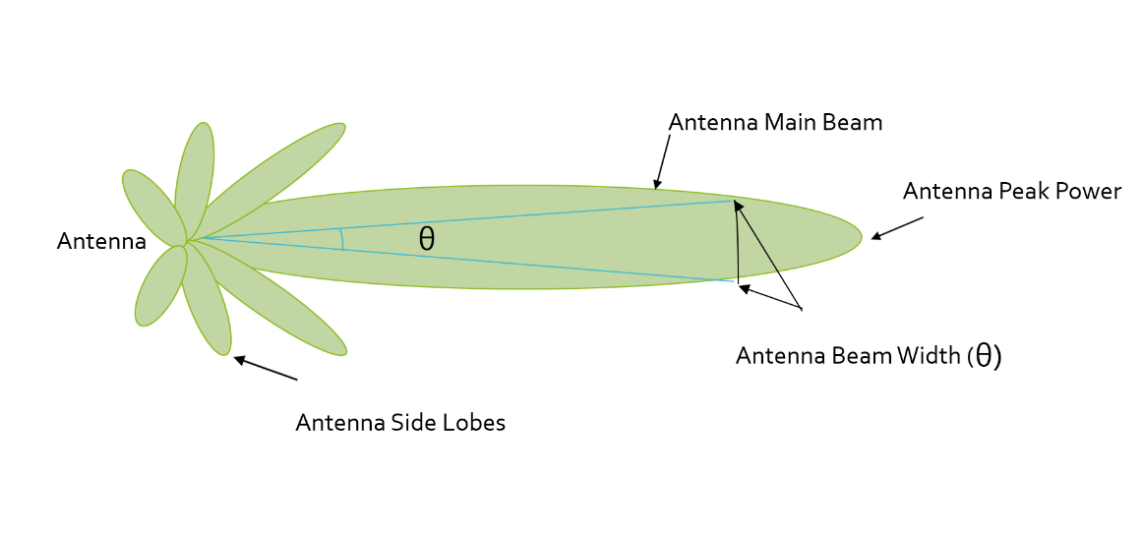

Antenna radiation not only comprises of the main beam but the sidelobes as well. Antenna sidelobes are critical because they can generate false alarms and pick interference from undesired direction. As seen in the pattern, the sidelobes of the antenna point in different directions and can sense targets that are not in the main beam. To avoid sidelobe detections it is critical to suppress the sidelobe levels to more than 30dB from the peak of the main beam.

**Antenna Types**

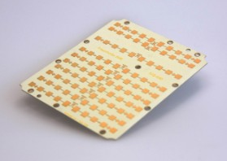

There are many types of antenna (dipole, patch, horn) that can be used at 77GHz, but the most commonly used antenna type in automotive radar is the patch antenna . The low cost, easy fabrication, and low profile of Patch Array Antennas makes them an ideal choice for automotive radar applications.

### Radar Cross Section

**Radar Cross Section Overview**

The size and ability of a target to reflect radar energy is defined by a single term, σ, known as the radar cross-section, which has units of $m^{2}.$ This unit shows that the radar cross section is an area. The target radar cross sectional area depends on:

* The target’s physical geometry and exterior features:  
  Smooth edges or surface would scatter the waves in all directions, hence lower RCS. Whereas, sharp corners will focus the return signal back in the direction of the source leading to higher RCS. (Image below for different target geometries)
* The direction of the illuminating radar
* The radar transmitter’s frequency
* The material used in the cars, trucks, bicycles, and even in some cases, the clothing material for pedestrians.

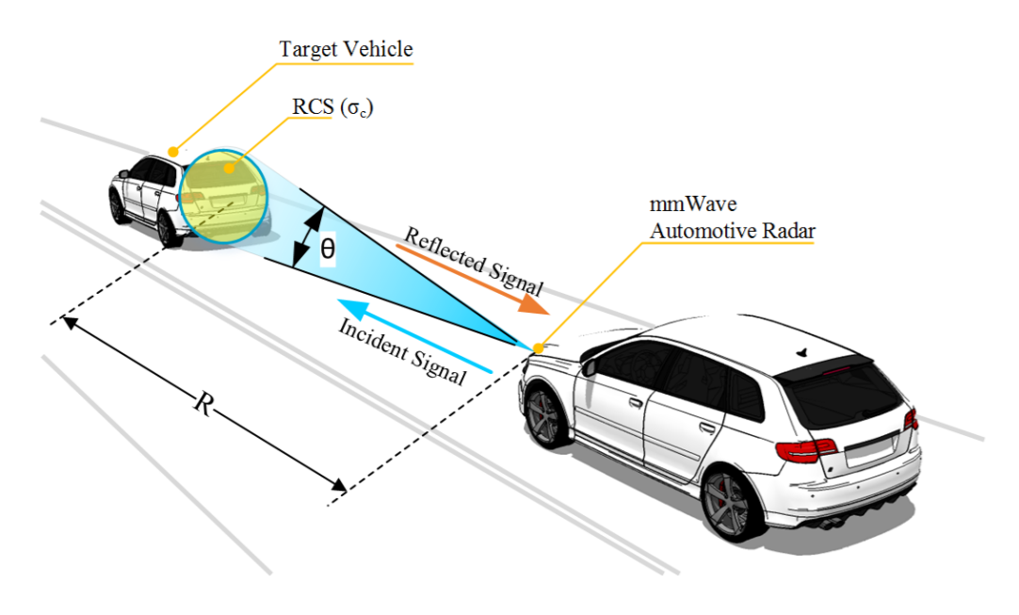

If absolutely all of the incident radar energy on the target were reflected equally in all directions, then the radar cross section would be equal to the target's cross-sectional area as seen by the transmitter. In practice, some energy is absorbed and the reflected energy is not distributed equally in all directions. Therefore, the radar cross-section is quite difficult to estimate and is normally determined by measurement.

Returns from different target geometries:

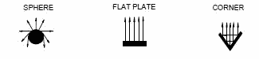

**RCS Units**

This RCS can also be defined using a logarithmic value (dB), since it increases the return signal strength. The formula for converting from RCS to dB is given by:

${RCS}_{dB}=10*\log\left({RCS}_{m^{2}}\right)$

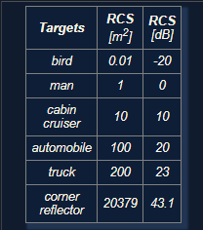

### Radar Range Equation

**Range Equation Overview**

Using the Radar Range equation we can design the radar transmitter, receiver, and antenna to have the desired power, gain and noise performance to meet the range requirements.

A long range radar designed to cover 300m range and detect a target with smaller cross section would need higher transmit power and more antenna gain as compared to a short range radar designed to cover just 50m for similar target. A target with higher cross section can be detected at a longer range as compared to a target with smaller cross section.

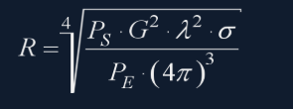

* $R$- Maximum Range a radar can detect targets.
* $P_{s}$- Transmitted Power from Radar ($dBm$)
* $G$- Gain of the Transmit/Receive Antenna ($dBi$)
* $λ$- Wavelength of the signal ($m$)
* $σ$- radar cross section ($m^{2})$
* $P_{E}$- Minimum received power radar can detect

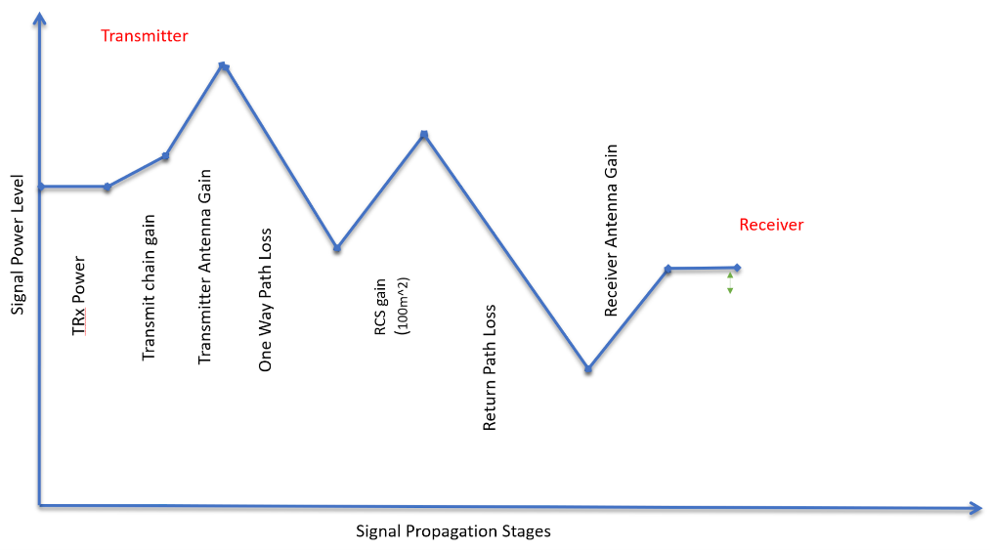

The image above shows the variation in the signal strength level as it travels through transmitter, over the air and at the receiver

The image above shows the variation in the signal strength level :

* The transmitter power
* Power Amplifiers further increase the signal strength - Transmit chain gain
* Signal is further amplified using an antenna
* One Way Path Loss represents the loss in the signal strength as it travels towards the target
* On getting reflected from the target the signal gets amplified based on the RCS of the target
* After RCS gain the signal travel back towards the radar and has similar loss in strength as going forward
* The receiver antenna amplifies the return signal before sending it to the processing unit

**Radar Detection**

Below is an illustration showing the output of a radar's range detection. The peaks correspond to the strength of the return signal from targets and the frequency relates to the range. Relationship between frequency and range will be discussed in next lesson.

A radar cannot detect a signal that is below the noise level. The noise level is determined by the thermal noise generated by the receiver. To successfully detect a target, the return signal strength needs to be larger than the noise level. This is defined by a property called signal to noise ratio, or SNR.

SNR is a quantitative measure of a signal strength as compared to the level of noise. If the SNR is too low it becomes difficult for a radar to distinguish the signal from noise. Hence, higher SNR is desirable for successful detection of the target. Generally, a 7-13 dB SNR ensures successful detection in a road scenario.

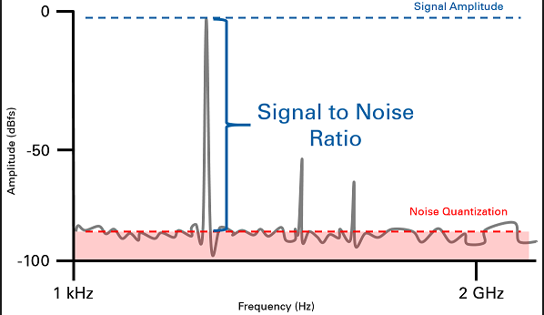

The image above shows the logarithmic value of SNR = power level (in dBm) - noise level (dBm). The plot shows the output of Range FFT. In general, the higher the SNR value, the greater are the chances of successful Radar detection.

### Placeholder

## Range-Doppler Estimation

### Range, Velocity and Angle Resolution

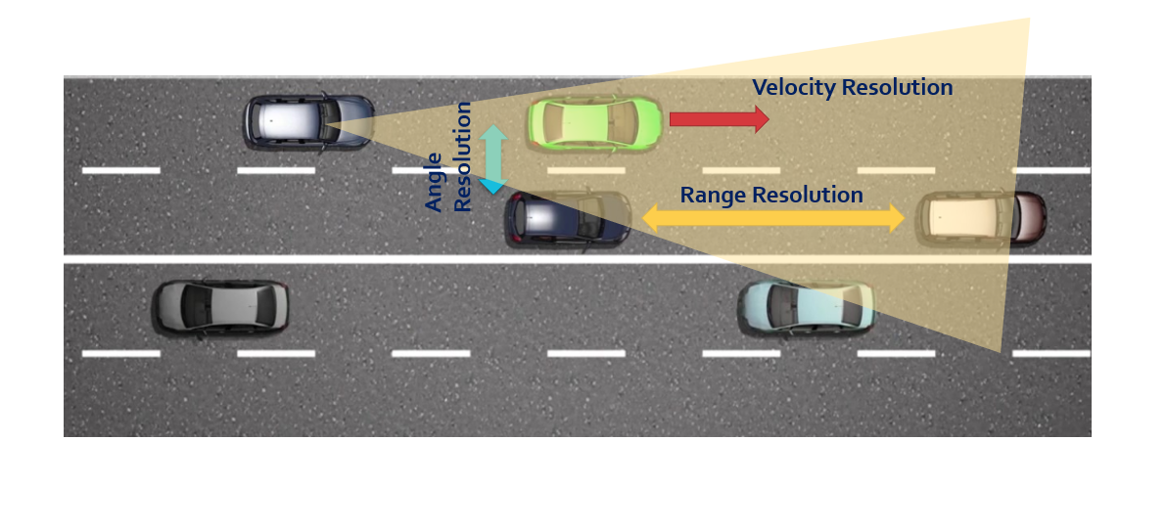

**Range Resolution**: It is the capability of the radar to distinguish between two targets that are very close to each other in range. If a radar has range resolution of 4 meters then it cannot separate on range basis a pedestrian standing 1 m away from the car.

The range resolution is solely dependent on the bandwidth of the chirp $B_{sweep}$:

$d_{res}= \frac{c}{2B_{sweep}}$

**Velocity Resolution**: If two targets have the same range they can still be resolved if they are traveling at different velocities. The velocity resolution is dependent on the number of chirps. As discussed for our case we selected to send 128 chirps. A higher number of chirps increases the velocity resolution, but it also takes longer to process the signal.

**Angle Resolution**: Radar is capable of separating two targets spatially. If two targets are at similar range travelling at same velocities, then they can still be resolved based on their angle in radar coordinate system. Angle resolution depends on different parameters depending on the angle estimation technique used.

### Range Estimation

**Range Estimation Overview**

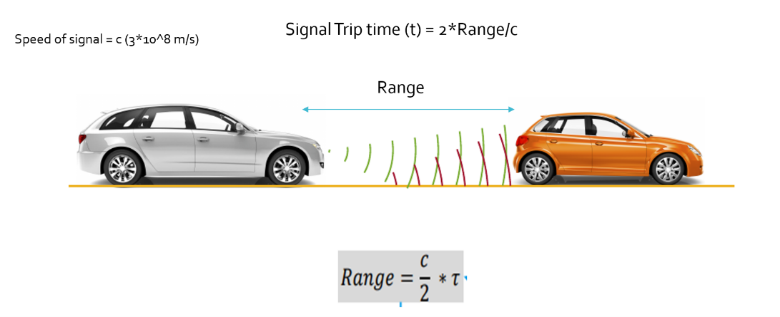

Radar determines the range of the target by measuring the trip time of the electromagnetic signal it radiates. It is known that EM wave travels at a known speed (300,000,000 m/s), so to determine the range the radar needs to calculate the trip time by measuring the shift in the frequency.

**Range Estimation Equation**

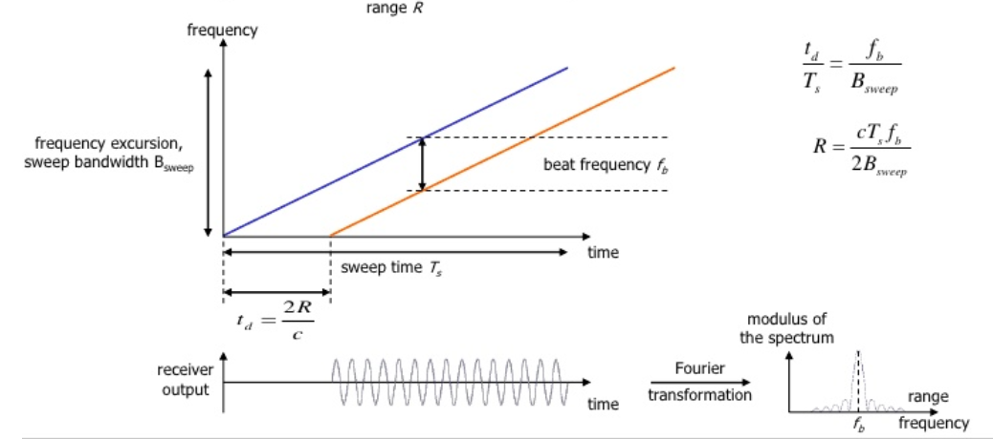

The FMCW waveform has the characteristic that the frequency varies linearly with time. If radar can determine the delta between the received frequency and hardware’s continuously ramping frequency then it can calculate the trip time and hence the range. We further divide Range estimate by 2, since the frequency delta corresponds to two way trip.

It is important to understand that if a target is stationary then a transmitted frequency and received frequency are the same. But, the ramping frequency within the hardware is continuously changing with time. So, when we take the delta (beat frequency) between the received and ramping frequency we get the trip time.

$R= \frac{cT_{s}f_{b}}{2B_{sweep}}$

Here, $f_{b}$ is the beat frequency, which is measured by the radar by subtracting the received frequency from the hardware’s ramping frequency:

$f_{b}= f_{ramping}- f_{received}$

As seen in the equation, the range calculation requires chirp time $T_{s}$ and chirp Bandwidth $B_{sweep}$. Those values are determined as we define the configuration of the radar based on its range resolution and trip time for Radar’s maximum range.

**System Level Range Calculation**

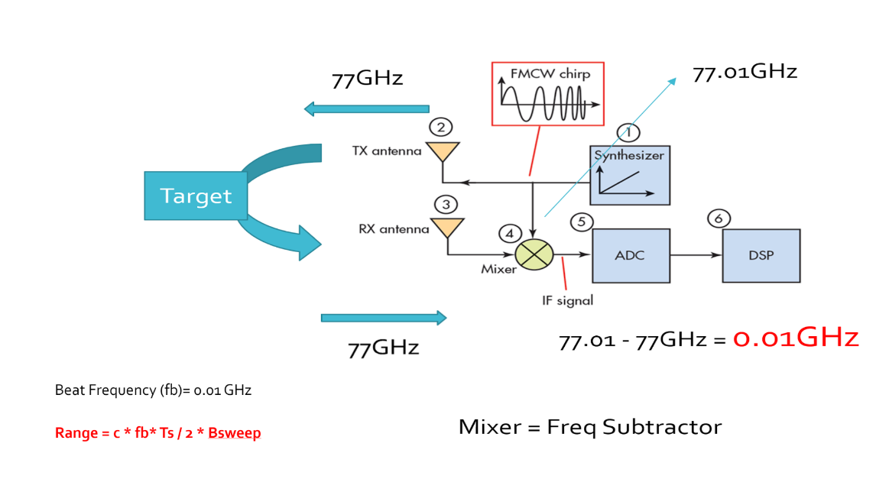

As seen in the image above, the Synthesizer generates FMCW chirp for a given $B_{sweep}$ and $T_{s}$. Let’s say the signal gets transmitted at 77GHz and it returns to the radar after hitting the target in a certain time duration. The radar receiver captures the signal, processes (subtraction) and measures the frequency delta between received signal and linearly ramping signal. This delta in frequency is called as beat frequency and it is proportional to the trip time. So based on the equation above, the radar calculates the range.

### Doppler Estimation

**Doppler Estimation Overview**

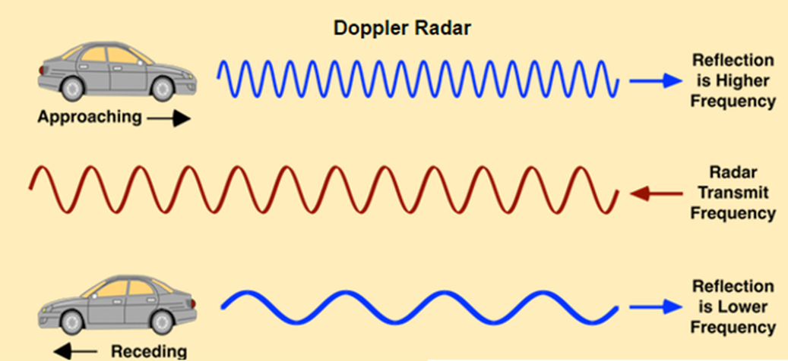

The velocity estimation for radar is based on an age old phenomenon called the doppler effect. As per doppler theory an approaching target will shift an emitted and reflected frequency higher, whereas a receding target will shift the both frequencies to be lower than the transmitted frequency.

**FMCW Doppler Measurements**

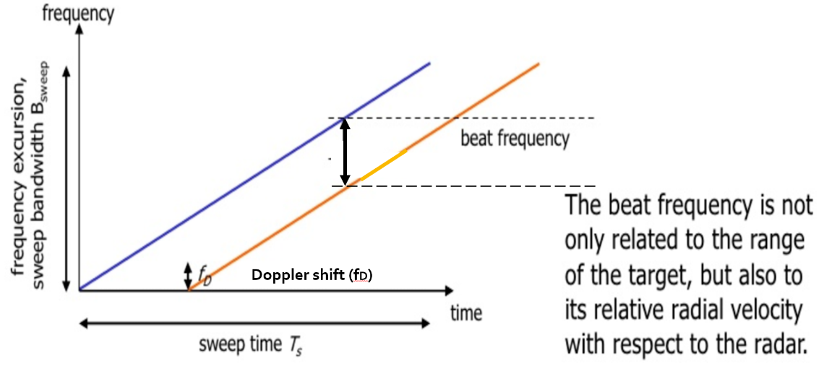

As discussed above, there will be a shift in the received signal frequency due to the doppler effect of the target’s velocity. The doppler shift is directly proportional to the velocity of the target as shown below:

$f_{D}= \frac{2v_{r}}{λ}$

$f_{D}$: shift in the transmitted frequency due to the doppler

$v_{r}$: relative velocity of the target

$λ$: wavelength of the signal

By measuring the shift in the frequency due to doppler, radar can determine the velocity. The receding target will have a negative velocity due to the frequency dropping lower, whereas the approaching target will have positive velocity as the frequency shifts higher.

The beat frequency comprises of both frequency components: $f_{r}$ (frequency delta due to range) and $f_{d}$ (frequency shift due to velocity). Although, in the case of automotive radar the $f_{d}$ is very small in comparison to the $f_{r}$. Hence, the doppler velocity is calculated by measuring the rate of change of phase across multiple chirps.

The following equation shows the relationship between the rate of change of the phase $φ$, and the frequency:

$$\frac{dφ}{dt}= frequency$$

**Doppler Phase Shift**

Keeping that in consideration, we calculate the doppler frequency by measuring the rate of change of phase. The phase change occurs due to small displacement of a moving target for every chirp duration. Since, each chirp duration is generally in microseconds, it results in small displacement in mm (millimeters). These small displacements for every chirp leads to change in phase. Using this rate of change of phase we can determine the doppler frequency.

If the path between a target and the radar is changed by an amount Δx, the phase of the wave received by radar is shifted by

$Δφ= \frac{Δx}{λ} \left(λ=2π or 360˚\right)$ $$Δφ=f* \frac{Δx}{c} (λ= f/c)$$

where λ and f are, respectively, the wavelength and frequency of the signal and c is the speed of propagation. The resulting change in observed frequency is

$Δf= \frac{Δφ}{Δt}$

where $Δt$ is the time taken for the observation of the phase change.

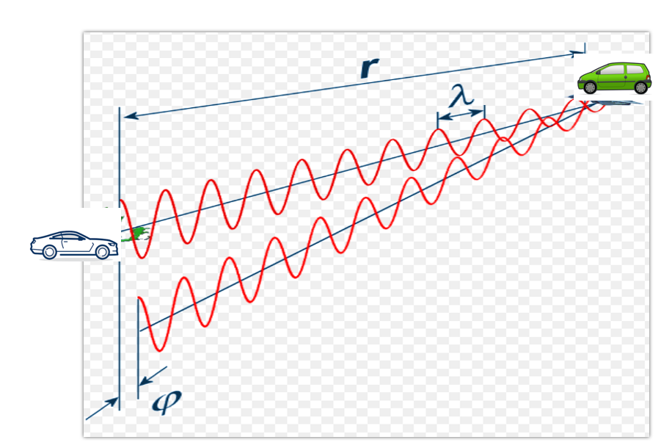

### Fast Fourier Transform

**FFT Overview**

So far we discussed the theory of range and doppler estimation along with the equations to calculate them. But, for a radar to efficiently process these measurements digitally, the signal needs to be converted from analog to digital domain and further from time domain to frequency domain.

ADC (Analog Digital Converter) converts the analog signal into digital. But, post ADC the Fast Fourier Transform is used to convert the signal from time domain to frequency domain. Conversion to frequency domain is important to do the spectral analysis of the signal and determine the shifts in frequency due to range and doppler.

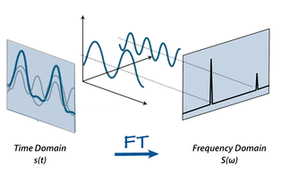

The traveling signal is in time domain. Time domain signal comprises of multiple frequency components as shown in the image above. In order to separate out all frequency components the FFT technique is used. FFT gives the frequency response of the return signal with each peak in frequency spectrum representing the detected target’s characteristics.

**FFT and FMCW**

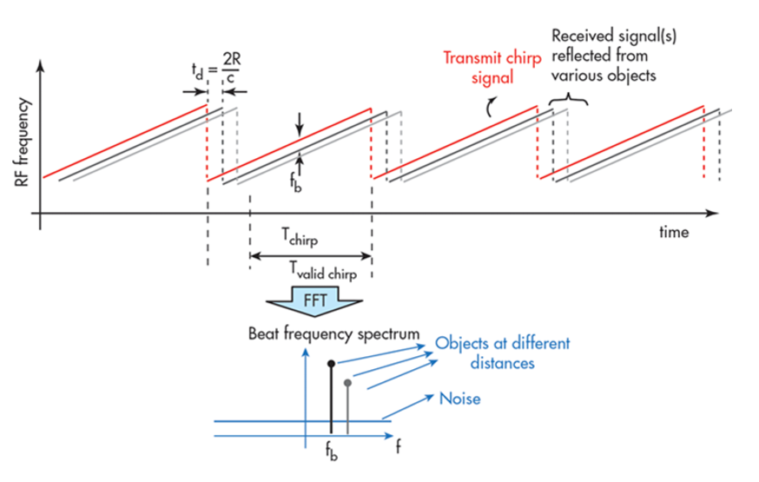

As seen in the image below, the Range FFTs are run for every sample on each chirp. Since each chirp is sampled N times, it will generate a range FFT block of N * (Number of chirps). These FFT blocks are also called FFT bins.

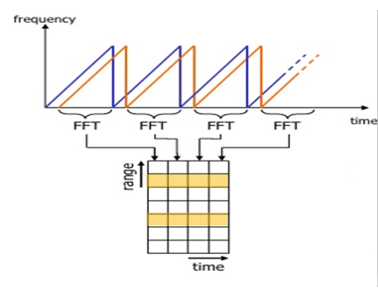

Range FFT

Each chirp is sampled N times, and for each sample it produces a range bin. The process is repeated for every single chirp. Hence creating a FFT block of N*(Number of chirps).

Each bin in every column of block represents increasing range value, so that the end of last bin represents the maximum range of a radar.

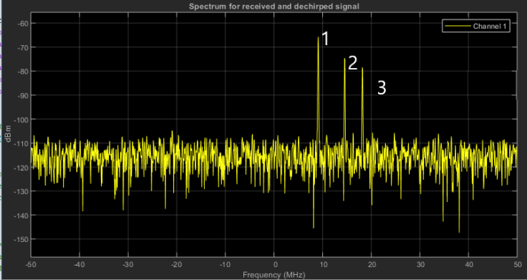

Output of Range FFT in MATLAB. X-axis = Beat Frequency, Y-axis = Signal power in dBm

Above is the output of the 1st stage FFT (i.e Range FFT). The three peaks in the frequency domain corresponds to the beat frequencies of three different cars located at 150, 240 and 300 m range from the ego vehicle.

### The 2D FFT

Once the range bins are determined by running range FFT across all the chirps, a second FFT is implemented along the second dimension to determine the doppler frequency shift. As discussed, the doppler is estimated by processing the rate of change of phase across multiple chirps. Hence, the doppler FFT is implemented after all the chirps in the segment are sent and range FFTs are run on them.

The output of the first FFT gives the beat frequency, amplitude, and phase for each target. This phase varies as we move from one chirp to another (one bin to another on each row) due to the target’s small displacements. Once the second FFT is implemented it determines the rate of change of phase, which is nothing but the doppler frequency shift.

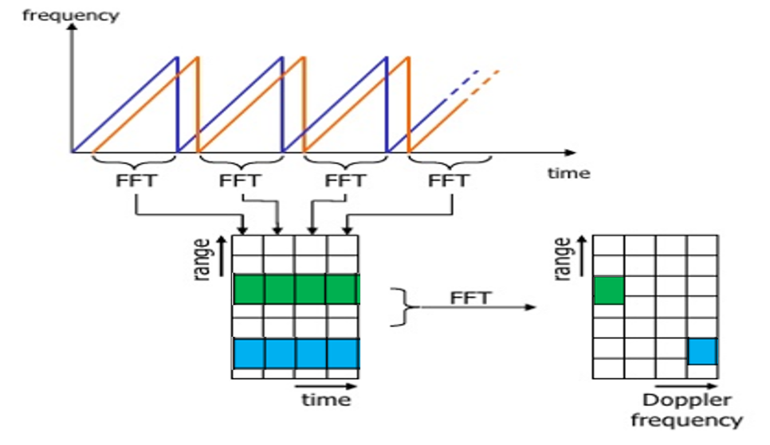

After running 2nd FFT across the rows of FFT block we get the doppler FFT. The complete implementation is called 2D FFT.

After 2D FFT each bin in every column of block represents increasing range value and each bin in the row corresponds to a velocity value. The output of Range Doppler response represents an image with Range on one axis and Doppler on the other. This image is called as Range Doppler Map (RDM). These maps are often used as user interface to understand the perception of the targets.

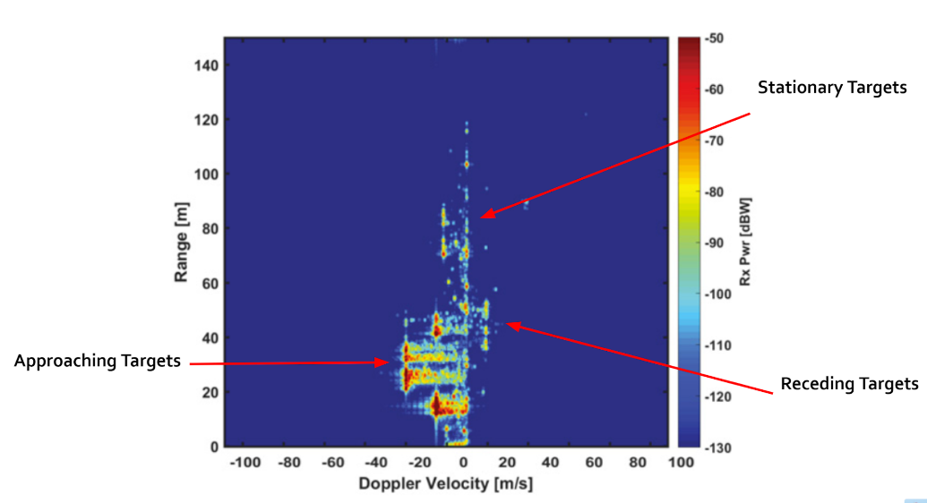

### Placeholder

* + 1. ff

## Clutter, CFAR, AoA

### Clutter

Radar not only receives the reflected signals from the objects of interest, but also from the environment and unwanted objects. The backscatter from these unwanted sources is called clutter.

These unwanted signals are generally produced by reflections from the ground, sea, buildings, trees, rain, fog etc. The magnitude of the clutter signal depends upon:

* The nature of the surface - ground, water, snow (e.g deserts have low reflectivity, whereas the frozen snow has high reflectivity)
* Smoothness of the surface
* Grazing angle - Angle the radar beam makes with the surface
* Radar Frequency

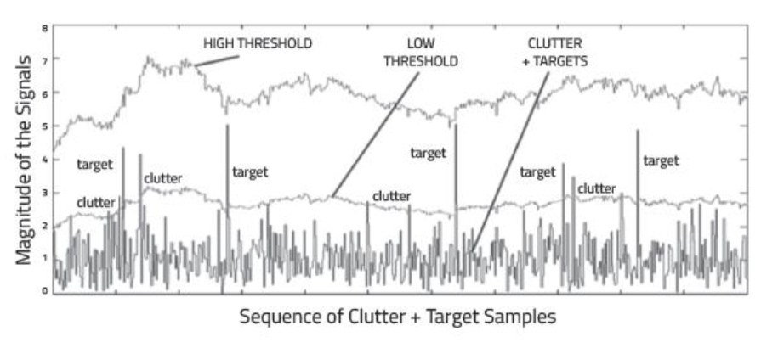

Return Signal from multiple targets along with some from the clutter

**Clutter Thresholding**

It is important to filter out clutter for successful detection of targets. This is critical in a driving scenario to avoid the car from suddenly braking in the absence of valid targets. This sudden braking happens when the radar detects reflections that are generated from the clutter.

One technique to remove clutter is to remove the signals having 0 doppler velocity. Since, the clutter in the driving scenario are often created by the stationary targets, the 0 doppler filtering can help get rid of them.

The downside of 0 doppler filtering is that the radar would not be able to detect the stationary targets in its path. This would lead to detection failures.

Another technique is to use fixed clutter thresholding. With fixed thresholding, signal below the threshold value is rejected. With this method, if the detection threshold is set too high, there will be very few false alarms, but it will also mask the valid targets. If the threshold is set too low, then it would lead to too many false alarms. In other words, the false alarm rate would be too high.

The false alarm rate is the rate of erroneous radar detections by noise or other interfering signals. It is a measure of the presence of detected radar targets when there is no valid target present.

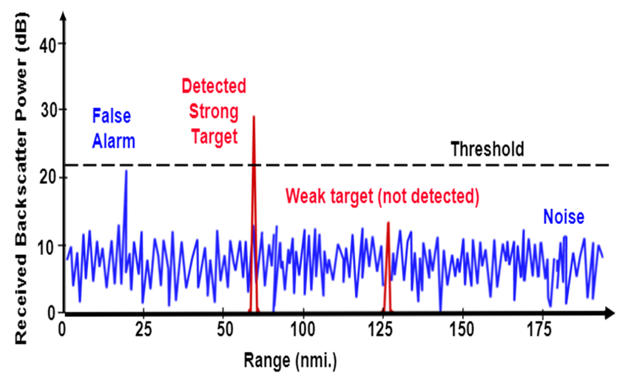

Fixed Threshold leading to False Alarms and missed detections of weak target

**Dynamic Thresholding**

Another approach to clutter thresholding is to use dynamic thresholding. Dynamic thresholding involves varying the threshold level to reduce the false alarm rate.

CFAR (Constant False Alarm Rate) is a dynamic thresholding technique. With this technique, the noise at every or group of range/doppler bins is monitored and the signal is compared to the local noise level. This comparison is used to create a threshold which holds the false alarm rate constant.

### CFAR

CFAR

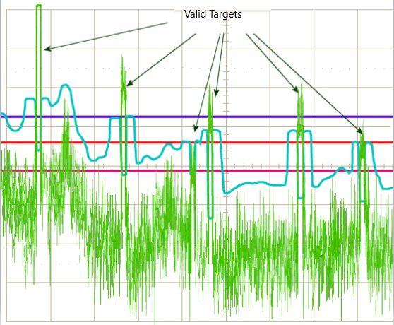

CA-CFAR and OS-CFAR

The false alarm issue can be resolved by implementing the constant false alarm rate. CFAR varies the detection threshold based on the vehicle surroundings. The CFAR technique estimates the level of interference in radar range and doppler cells “Training Cells” on either or both the side of the “Cell Under Test”. The estimate is then used to decide if the target is in the Cell Under Test (CUT).

The process loops across all the range cells and decides the presence of target based on the noise estimate. The basis of the process is that when noise is present, the cells around the cell of interest will contain a good estimate of the noise, i.e. it assumes that the noise or interference is spatially or temporarily homogeneous. Theoretically it will produce a constant false alarm rate, which is independent of the noise or clutter level.

There are multiple categories of CFAR:

* Cell Averaging CFAR (CA-CFAR)
* Ordered Statistics CFAR (OS CFAR)
* Maximum Minimum Statistic (MAMIS CFAR)
* And, multiple variants of CA-CFAR.

Here, we will be covering the basic CA-CFAR.

### CA-CFAR

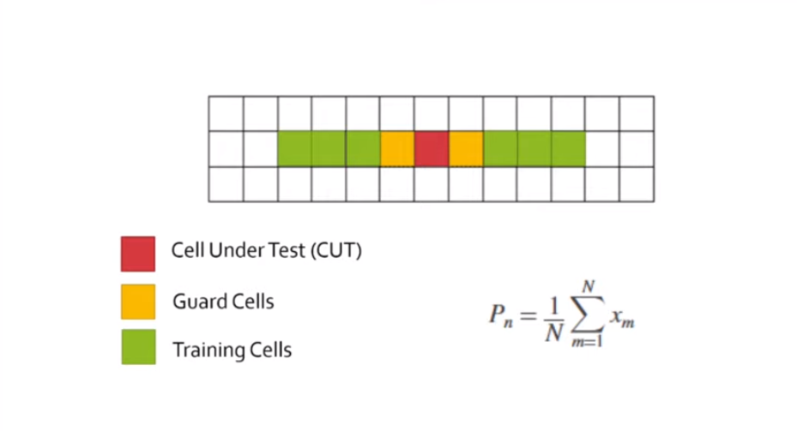

CA-CFAR Training Cells : 3 Guard Cell : 1

CA-CFAR is the most commonly used CFAR detection technique. As seen in the previous lesson, the FFT blocks are generated on implementing range and doppler FFTs across the number of chirps. The CFAR process includes the sliding of a window across the cells in FFT blocks. Each window consists of the following cells.

**Cell Under Test** : The cell that is tested to detect the presence of the target by comparing the signal level against the noise estimate (threshold).

**Training Cells** : The level of noise is measured over the Training Cells. The Training Cells can be divided into two regions, the cells lagging the CUT, called lagging Training Cells and the cells leading the CUT, called Leading Training Cells. The noise is estimated by averaging the noise under the training cells. In some cases either leading or lagging cell average is taken, while in the other the leading and lagging cell average is combined and the higher of two is considered for noise level estimate.The number of training cells should be decided based on the environment. If a dense traffic scenario then the fewer training cells should be used, as closely spaced targets can impact the noise estimate.

**Guard Cells** : The cells just next to CUT are assigned as Guard Cells. The purpose of the Guard Cells is to avoid the target signal from leaking into the training cells that could adversely affect the noise estimate. The number of guard cells should be decided based on the leakage of the target signal out of the cell under test. If target reflections are strong they often get into surrounding bins.

**Threshold Factor (Offset)** : Use an offset value to scale the noise threshold. If the signal strength is defined in logarithmic form then add this offset value to the average noise estimate, else multiply it.

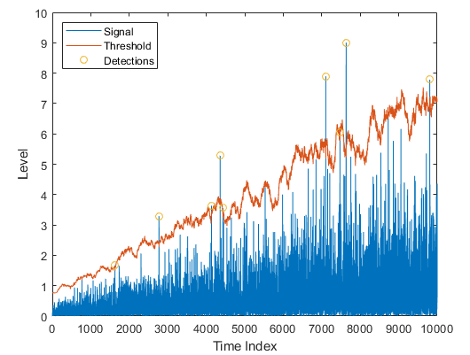

### CFAR 2D

The 2D CFAR is similar to 1D CFAR, but is implemented in both dimensions of the range doppler block. The 2D CA-CFAR implementation involves the training cells occupying the cells surrounding the cell under test with a guard grid in between to prevent the impact of a target signal on the noise estimate.

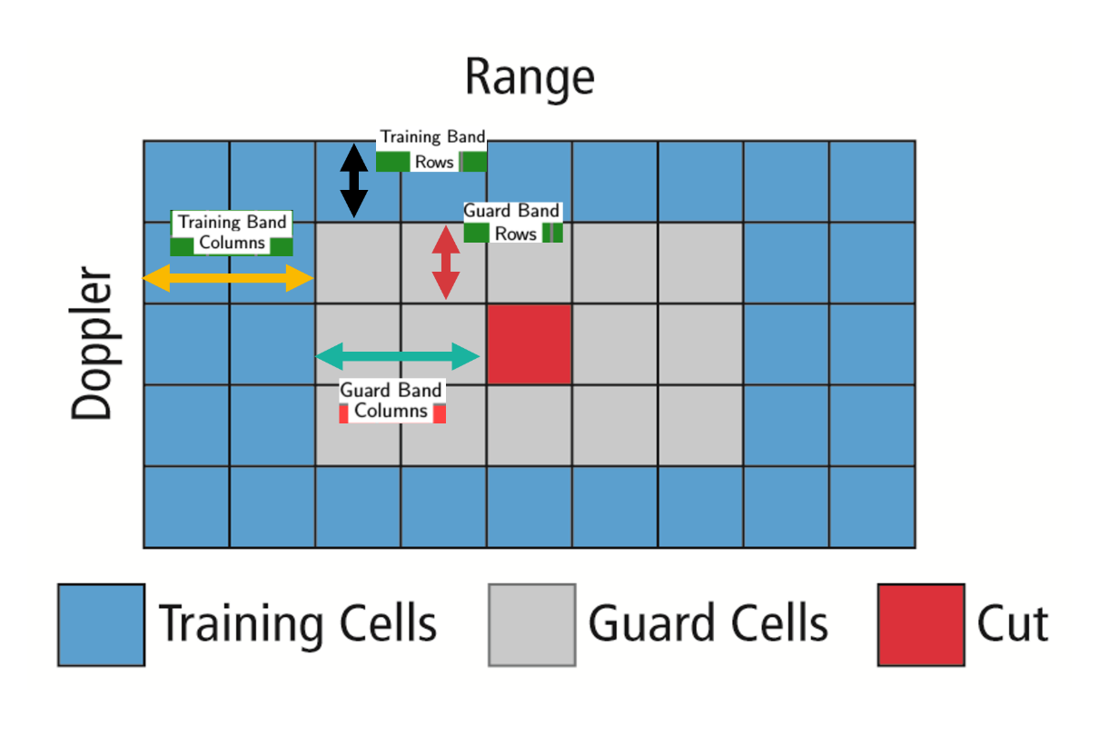

### Angle of Arrival

A phased array antenna is an antenna array that steers the beam electronically in the desired direction. The array steers the beam if each antenna element in an array is excited by the signal with certain phase values. This phenomenon is referred to as beam scanning.

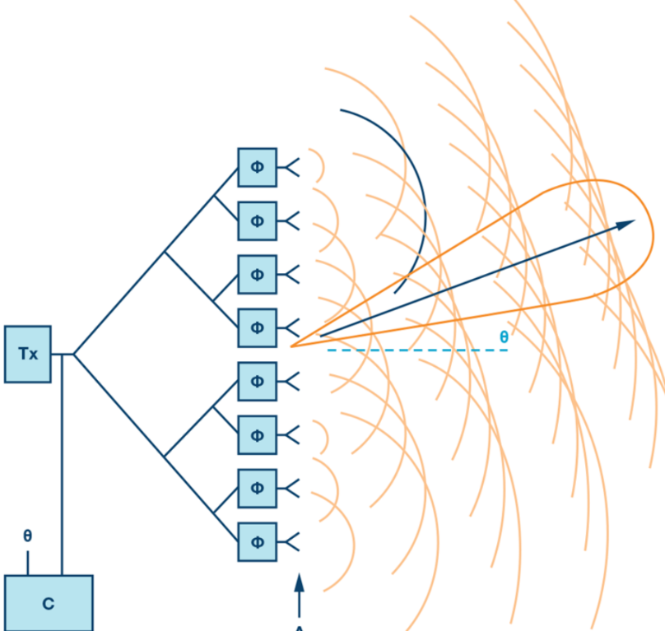

Beam Steering Design.

Here the Φ represents the phase shifters. Phase shifters are the electronic components that changes the phase to make the beam steer in a desired direction.

For antenna beam to steer in a desired direction, the phase shifters are programmed to have constant phase increments. If an antenna comprises of six radiating elements and the phase delta required to steer a beam in a given direction is 15 degrees, then the following would be the phase value on each element [0,15,30,45,60,75] degrees. The increment phase shift along with the spacing between antenna elements (d) determines the steering angle of an antenna using the following equation

$Φ=360*d*sin⁡(Θ)/λ$

* $Φ$ = incremental phase shift
* $d$ = spacing between antenna elements
* $Θ$ = steering direction from normal of the antenna surface
* $λ$ = wavelength of the signal

As the radar scan the surroundings by steering the beam at the programmed angles, it can sense the angle of the return signal. This helps Radar create a spatial perception of the environment.

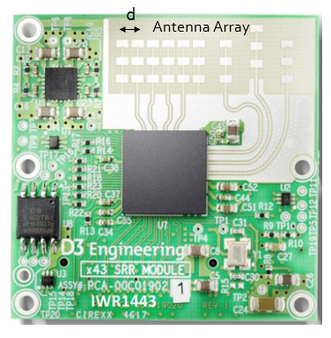

As the radar scans the surroundings by steering the beam at the programmed angles, it measures the SNR of reflected signals from targets located at different angles spatially. This helps in creating an angle of arrival vs SNR grid for radar’s spatial perception.

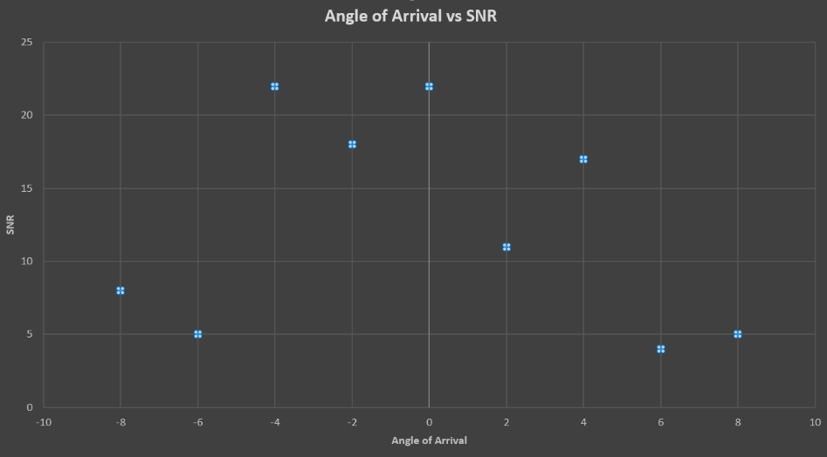

* + 1. Placeholder

## Clustering and Tracking

### Clustering

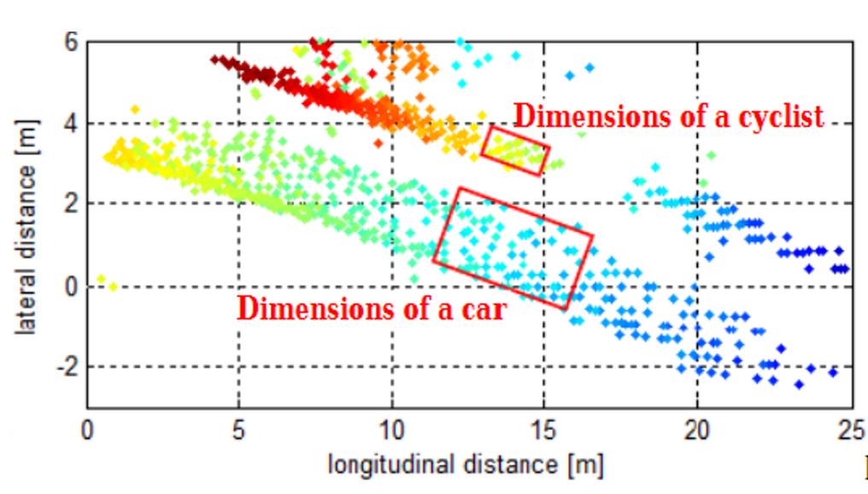

Clustering of a car and bicycle

For enhanced perception in autonomous driving, there is a need to track multiple targets separately. The object tracking is computationally expensive and tracking multiple targets simultaneously requires lots of processing power and memory.

Due to the advancements in radar technology and increasing sensing resolutions, a radar can generate detections from plentitude of scattering points on the target. If a tracker is assigned to every detection from the same target, then it can overburden the processing unit. Hence, it is important to cluster the detections from every target and assign a single track for each.

Here we will discuss the basic clustering algorithm based on the euclidean distance. The algorithm here groups the detection points based on their proximity measured by the euclidean distance between those points.

All the detection points that are within the size of the target are considered as one cluster, merged into a centroid position. Each cluster is now assigned a new range and velocity, which is the mean of measured range and velocity of all the detection points that form the cluster.

This allows valid tracking for each target.

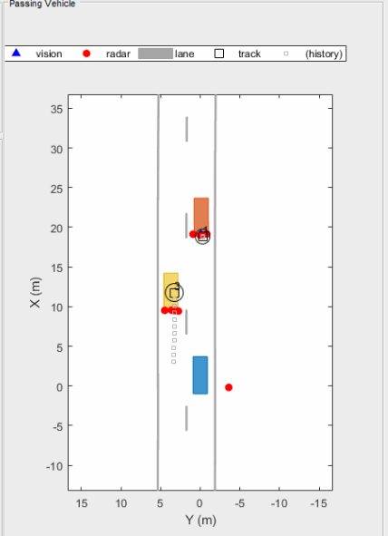

Above is an illustration of the clustering scenario. In the image the blue car is an ego vehicle (vehicle with sensor) and the detections are generated from the orange and yellow vehicles. Using clustering algorithm all the detections associated with the single target are merged into one point. This helps in the detection and assigning the tracks to a target.

### Kalman Tracking

**MATLAB Sensor Fusion**

Sensor fusion and control algorithms for automated driving systems require rigorous testing. Vehicle-based testing is not only time consuming to set up, but also difficult to reproduce. Automated Driving System Toolbox provides functionality to define road networks, actors, vehicles, and traffic scenarios, as well as statistical models for simulating synthetic radar and camera sensor detection. This example shows how to generate a scenario, simulate sensor detections, and use sensor fusion to track simulated vehicles. The main benefit of using scenario generation and sensor simulation over sensor recording is the ability to create rare and potentially dangerous events and test the vehicle algorithms with them.

* + 1. Placeholder

## Radar Target Generation and Detection

### Radar Target Generation and Detection

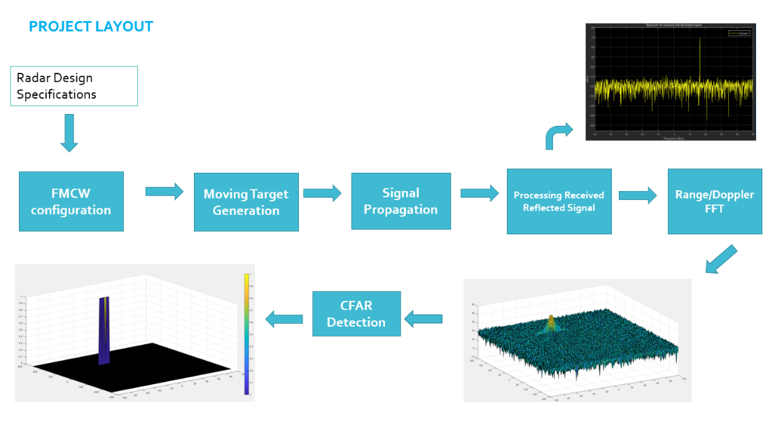

* Configure the FMCW waveform based on the system requirements.
* Define the range and velocity of target and simulate its displacement.
* For the same simulation loop process the transmit and receive signal to determine the beat signal
* Perform Range FFT on the received signal to determine the Range
* Towards the end, perform the CFAR processing on the output of 2nd FFT to display the target.

**Radar System Requirements**

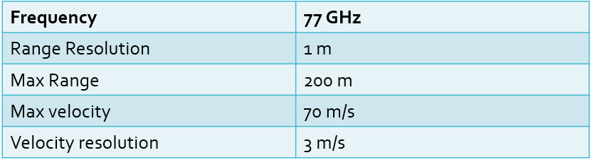

System Requirements defines the design of a Radar. The sensor fusion design for different driving scenarios requires different system configurations from a Radar. In this project, you will designing a Radar based on the given system requirements (above). Max Range and Range Resolution will be considered here for waveform design.

* The sweep bandwidth can be determined according to the range resolution and the sweep slope is calculated using both sweep bandwidth and sweep time.
$$Bandwidth\left(B_{sweep}\right)= \frac{speed of light}{2*rangeResolution}$$

* The sweep time can be computed based on the time needed for the signal to travel the unambiguous maximum range. In general, for an FMCW radar system, the sweep time should be at least 5 to 6 times the round trip time. This example uses a factor of 5.5.Giving the slope of the chirp signal

$$T_{chirp}=5.5* \frac{2R_{max}}{c}$$

Giving the slope of the chirp signal

$$Slope= \frac{Bandwidth}{T_{chirp}}$$

**Initial Range and Velocity of the Target**

You will provide the initial range and velocity of the target. Range cannot exceed the max value of 200m and velocity can be any value in the range of -70 to + 70 m/s.

**Target Generation and Detection**

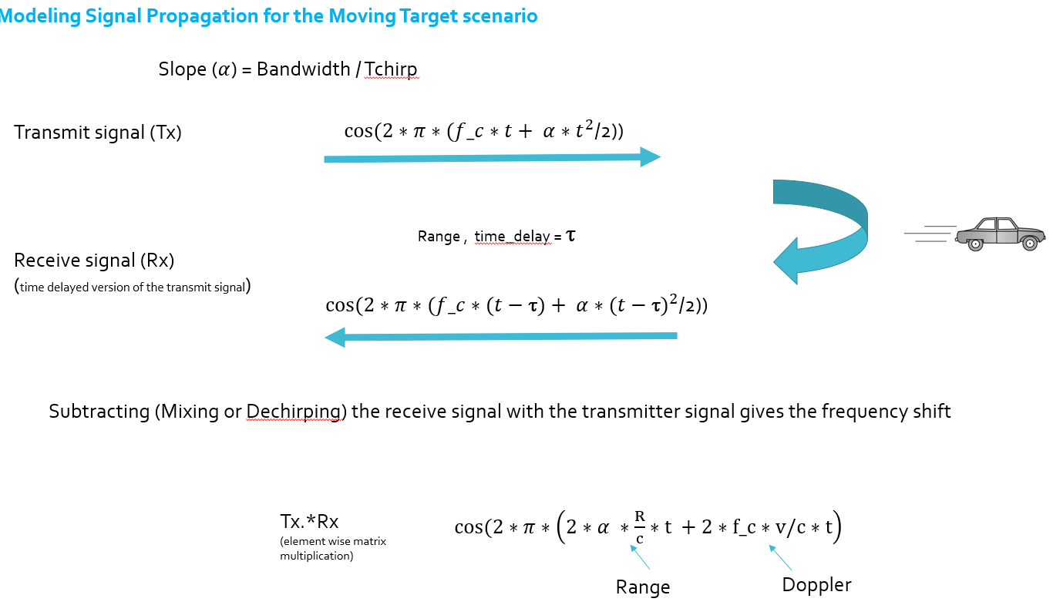

Next, you will be simulating the signal propagation and moving target scenario.

Theory : In terms of wave equation, FMCW transmit and receive signals are defined using these wave equations, where α = *Slope of the signal*. The Transmit Signal is given by:

$$T_{x}=\cos\left(2π\left(f_{c}t+ \frac{αt^{2}}{2}\right)\right)$$

The received signal is nothing but the time delayed version of the Transmit Signal. In digital signal processing the time delayed version is defined by $(t- τ)$, where $τ$ represents the delay time, which in radar processing is the trip time for the signal.

Replacing $t$ with $(t- τ)$ gives the Receive Signal:

$$R_{x}= \cos\left(2π\left(f_{c}(t-τ)+ \frac{α{(t- τ)}^{2}}{2}\right)\right)$$

On mixing these two signals, we get the beat signal, which holds the values for both range as well as doppler. By implementing the 2D FFT on this beat signal, we can extract both Range and Doppler information.

The beat signal can be calculated by multiplying the Transmit signal with Receive signal. This process in turn works as frequency subtraction. It is implemented by element by element multiplication of transmit and receive signal matrices.

$$Mixed or Beat Signal=\left(T_{x}.*R_{x}\right)$$

$$T_{x}.*R_{x}= \cos\left(2π\left(\frac{2αR}{c}t+ \frac{2f_{c}v}{c}t\right)\right)$$

**FFT Operation**

* Implement the 1D FFT on the Mixed Signal
* Reshape the vector into Nr*Nd array.
* Run the FFT on the beat signal along the range bins dimension (Nr)
* Normalize the FFT output.
* Take the absolute value of that output.
* Keep one half of the signal
* Plot the output
* There should be a peak at the initial position of the target

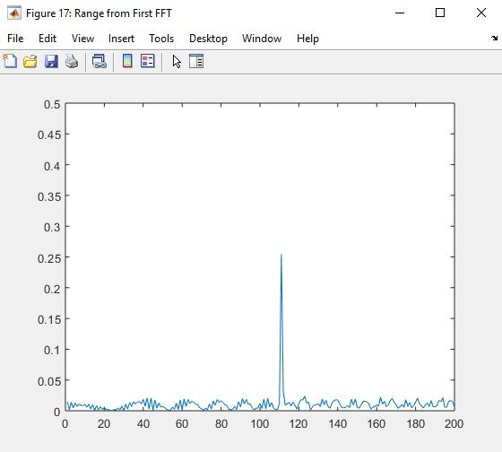

The 1st FFT output for the target located at 110 meters

The 2nd FFT is already implemented in the code. It will generate a Range Doppler Map as seen in the image below and it will be given by variable ‘RDM’. Next task is to implement the CFAR on this Range Doppler Map.

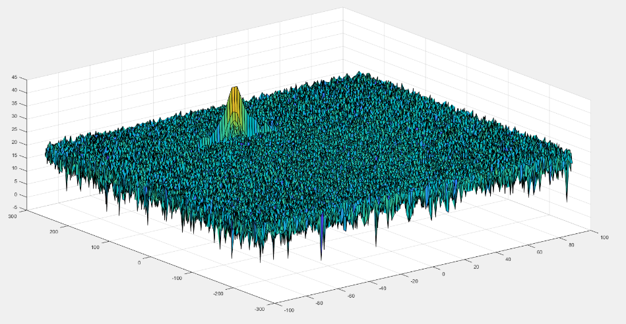

2D FFT output - Range Doppler Map

**2D CFAR**

* Determine the number of Training cells for each dimension. Similarly, pick the number of guard cells.
* Slide the cell under test across the complete matrix. Make sure the CUT has margin for Training and Guard cells from the edges.
* For every iteration sum the signal level within all the training cells. To sum convert the value from logarithmic to linear using db2pow function.
* Average the summed values for all of the training cells used. After averaging convert it back to logarithmic using pow2db.
* Further add the offset to it to determine the threshold.
* Next, compare the signal under CUT against this threshold.
* If the CUT level > threshold assign it a value of 1, else equate it to 0.

The process above will generate a thresholded block, which is smaller than the Range Doppler Map as the CUTs cannot be located at the edges of the matrix due to the presence of Target and Guard cells. Hence, those cells will not be thresholded. To keep the map size same as it was before CFAR, equate all the non-thresholded cells to 0.

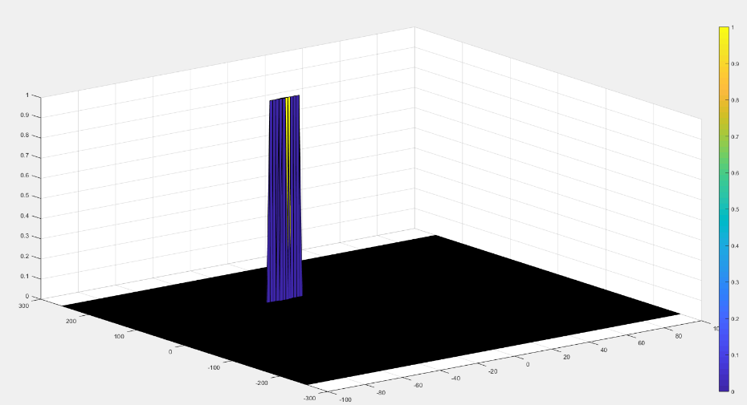

The output of the 2D CFAR process

Once you have completed this, you are done. Congratulations on doing a great job on this final project!

### 2.5.2 Placeholder

## Placeholder

# Camera

<https://classroom.udacity.com/nanodegrees/nd313-beta/parts/45d2275b-5183-4d45-84d9-50d113be93cb/modules/b52e21b1-f7ef-434a-9378-58b75dfa6800/lessons/7fb8e8ec-0246-4e1e-9d12-e3cdf11391b7/concepts/38df3cda-6708-40e8-b9e0-347d02339007>